CSE 581

**Lab 13: Functions**

**Steps:**

1. Create a function that will accept CourseId and Numerical Grade and will calculate the letter grade. The function will return the appropriate *Letter Grade Description* based on the input and the ***Course Grading*** table[1][2].

CREATE FUNCTION dbo.LetterGradeCalculation

(@CourseId int, @GradeValue float)

RETURNS table

return

SELECT TOP(1) x.LetterGrade

FROM

(SELECT CourseId, GradeValue, LetterGrade

FROM LetterGrades L INNER JOIN CourseGrade C

ON L.LetterGradeId = C.LetterGradeId) x

WHERE x.CourseId = @CourseId AND GradeValue <= @GradeValue

GO

1. Verify that the function works as expected:
   1. Run the function for the CourseId = 1, NumericalGrade = 95.
   2. Run the function for the CourseId = 2, NumericalGrade = 95.
   3. Run the function for the CourseId = 2, NumericalGrade = 85.

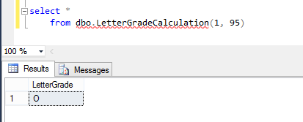

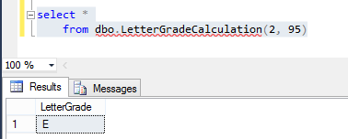

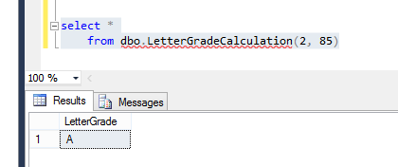

1.
2.